Homework # 11 – McNemar Item Analysis Assignment on WINDOWS.

Given Problem:
Item2 | Item1
Item2 | Fail | Pass
Pass | 10 | 6
Fail | 8 | 30

Null Hypothesis:
The probability of failing Item 1 and passing Item 2 is the same as the probability of failing Item 2 and passing Item 1.

Alternative Hypothesis:
The probability of failing Item 1 and passing Item 2 is not equal to the probability of failing Item 2 and passing Item1.

Hand Calculation:

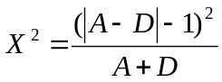 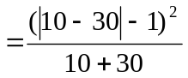 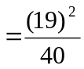 = 9.025

We have df = 1, and we know that the value of χ² for df = 1 is 3.84 for the alpha level .05, and 6.64 for the alpha level .01. As the calculated χ² = 9.025 is greater than the critical value of χ² = 6.64 at alpha level .01, the test was significant [χ² (1, N = 54) = 9.025, p < .01]. Thus, we reject the null hypothesis, and conclude that the probability of failing Item 1 and passing Item 2 was not equal to the probability of failing Item 2 and passing Item1.

Calculating Effect Size:

Item2 | Item1
Item2 | Fail | Pass | Total
Pass | 10 | 6 | 26
Fail | 8 | 30 | 38
Total | 18 | 36 | 54

The proportion of numbers who passes Item 1 is 36/54 = 0.67
The proportion of numbers who passes Item 2 is 26/54 = 0.48
Thus, the effect size = 0.67 - 0.48 = 0.19; which is small to medium
SPSS Data:

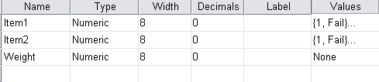

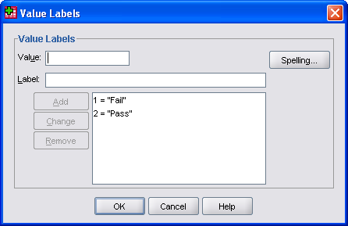

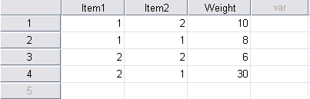

SPSS Command:

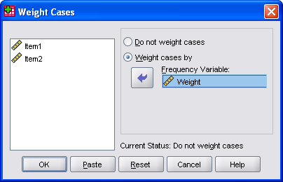

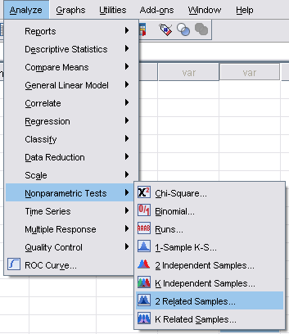

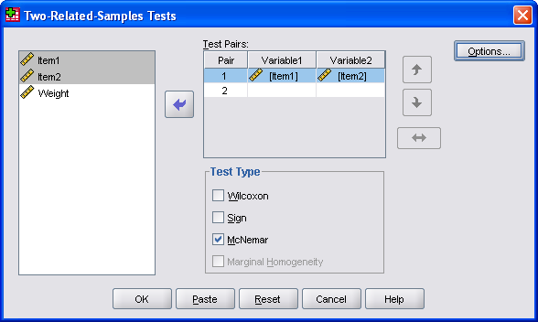

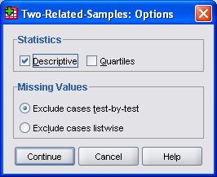

SPSS Output:
NPar Tests
Descriptive Statistics
 | N | Mean | Std. Deviation | Minimum | Maximum
Item1 | 54 | 1.67 | .476 | 1 | 2
Item2 | 54 | 1.30 | .461 | 1 | 2

McNemar Test
Crosstabs
Item1 & Item2
Item1 | Item2
Item1 | Fail |  | Pass
Fail | 8 |  | 10
Pass | 30 |  | 6
Test Statistics^{b}
 |  | Item1 & Item2
N |  | 54
Chi-Squareª |  | 9.025
Asymp. Sig. |  | .003
a. Continuity Corrected
b. McNemar Test

Conclusion:
To find out whether there was a difference in performance of students on test Items 1 and 2 a Macnemar Change test was carried out on the following data:

- Ten students passed Item 2 and failed Item 1
- Eight students failed Item 1 and failed Item 2
- Six students passed Item 1 and passed Item 2
- Thirty students failed Item 2 and passed Item 1.

The test was significant [χ² (1, N = 54) = 9.025, p = .003]. We reject the null hypothesis that there is equal likelihood to pass one item and fail the other. Actually, more students passed Item 1 (n = 30) than passed Item 2 (n = 10). The effect size was .19 which was small to medium.

